Activity 1 :

Making a directory in Linux under path : /home/rubal and creating a file hello.txt

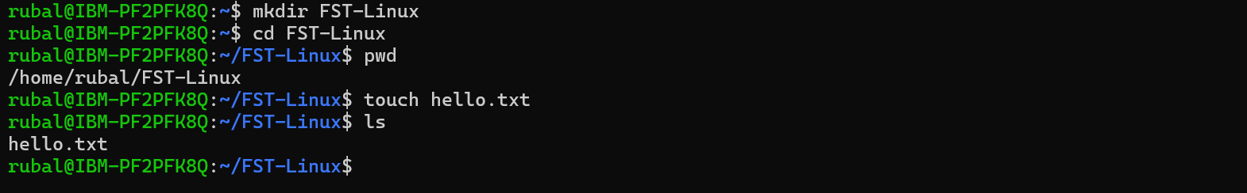

Screenshot for directory FST-Linux having file hello.txt

Rename the file hello.txt to bye.txt in ubuntu

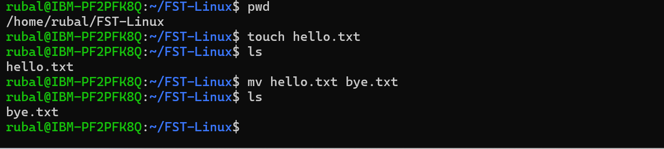

Screenshot for directory FST-Linux having file bye.txt

Removing/ Deleting the file bye.txt

Screenshot for directory FST-Linux having no file

